Order Form- Insoles

- Email - will be replaced by login id

- Orthotist Name:- *
* Mandatory
Red will not be there in the final version of the app

- Clinic Location:- *

USER DETAILS

- Your User Id: Patient/Case identifier
- Age
- Weight: Used to determine the overall device and reinforcement thickness
- Diagnosis: Used to determine the device specifications (which at the moment is being taken manually from the user- but we would want to create a database of this correlating with the device design to create establish some form pattern between the 2 and automate the whole design process)

MEASUREMENT DETAILS

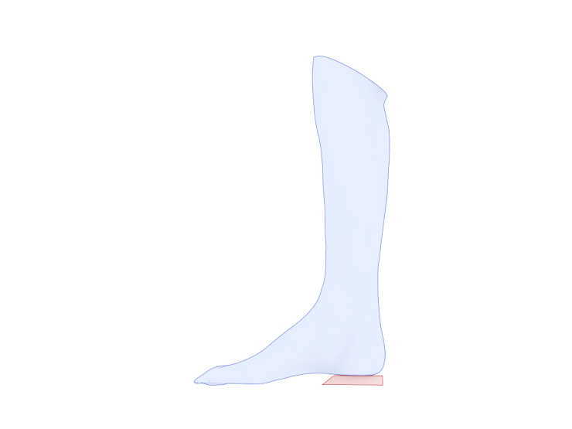

Heel height to be integrated in the insole: Would become a part of clinical or angular modifications eventually

- Which side is the insole for?

Left
Right
Bilateral

LEG INFORMATION

Along with scan, taking a few measurements of the limb help to maintain the precision and accuracyFoot length (in mm)

Make sure that the foot is in partial weight bearing so that it splays naturally, leave blank if not recorded.

- ML at Metatarsal heads (in mm)

- Foot length (in mm)

Calcaneal correction
In case of other please state varus or valgus and the desired angle.

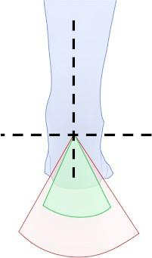

In case of others please state varus or valgus and the desired angle.
Eventually the software should be able to detect and apply the needed correction automatically from this field and just offer the option of any adjustments if needed by the user.

As scanned/casted
Neutral position
Other:

Insole shell thickness (Standard is 3 mm). Would become a part of the device specifications

2.5 mm
3 mm
Other:

Reinforcement ribs to prevent arch collapse

  - 1 mm (standard)
  - No
  - Other:

Additions would also include all the variations shown in the link below:
3D Printed - LaserCAM Orthotics KB - Confluence (atlassian.net)

Metatarsal Bar
Mention metatarsal head area for speciﬁc area weight relief. A standard relief is 5 mm in height

Metatarsal Pad

  - Yes
  - No

Heel

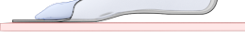
No Heel post

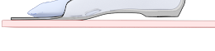
Heel Post minus heel height

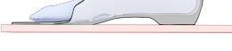
Heel post extending to the ground

- Additional Comments

LEFT LEG INFORMATION

Along with scan, taking a few measurements of the limb help to maintain the precision and accuracy

Foot length (in mm)

- ML at Metatarsal heads (in mm)
Make sure that the foot is in partial weight bearing so that it splays naturally, leave blank if not recorded

Calcaneal correction
In case of other please state varus or valgus and the desired angle.



Mark only one oval.

As scanned/casted Neutral position Other:

Insole shell thickness (Standard is 3 mm)

Mark only one oval.

2.5 mm 3 mm Other:

Reinforcement ribs to prevent arch collapse

Mark only one oval.

1 mm (standard) No
Other:

Additions

Metatarsal Bar
Mention metatarsal head area for speciﬁc area weight relief. A standard relief is 5 mm in height

Mark only one oval.

Forefoot width
Other:

Metatarsal Pad

Mark only one oval.

Yes No

Heel

Mark only one oval.



No Heel post Heel Post minus heel height


Heel post extending to the ground

Any text to be engraved on the lower side of the insoles?

Mark only one oval.

No
Other:

- Additional Comments

RIGHT LEG INFORMATION

Along with scan, taking a few measurements of the limb help to maintain the precision and accuracy

Foot length (in mm)

- ML at Metatarsal heads (in mm)
Make sure that the foot is in partial weight bearing so that it splays naturally, leave blank if not recorded

Calcaneal correction
In case of other please state varus or valgus and the desired angle.



Mark only one oval.

As scanned/casted Neutral position Other:

Insole shell thickness (Standard is 3 mm)

Mark only one oval.

2.5 mm 3 mm Other:

Reinforcement ribs to prevent arch collapse

Mark only one oval.

1 mm (standard) No
Other:

Additions

Metatarsal Bar
Mention metatarsal head area for speciﬁc area weight relief. A standard relief is 5 mm in height

Mark only one oval.

Forefoot width
Other:

Metatarsal Pad

Mark only one oval.

Yes No

Heel

Mark only one oval.



No Heel post Heel Post minus heel height


Heel post extending to the ground

Any text to be engraved on the lower side of the insoles?

Mark only one oval.

No
Other:

Additional Comments

This content is neither created nor endorsed by Google.

Forms

